Name: Trần Anh Tuấn
Student ID: 24521943
Class: CS4323.Q12.CTTT

OS
LAB 3

CHECKLIST
1. Homework
 | 1 | 2 | 3
Explanation
Your code
Results and discussions

Mark:
2. Lab 3
1. Given the file gradebook.csv which contain grades of a class. Research how to use IFS to read csv file. Use shell script to:
- Read Student ID from command line
- Use Student ID to find and print name, original grade, and letter-based grade of corresponding student

Answer:

Lookup_grade.sh
#!/bin/bash

# Check that a Student ID was provided
if [ $# -ne 1 ]; then
echo "Usage: $0 <StudentID>"
exit 1
fi

TARGET_ID=$1

while IFS=';' read -r sid name grade_raw; do
if [ "$sid" = "StudentID" ]; then
continue
fi
grade=${grade_raw//$'\r'/}
if [ "$sid" = "$TARGET_ID" ]; then
if [ "$grade" -ge 900 ]; then
letter="A"
elif [ "$grade" -ge 800 ]; then
letter="B"
elif [ "$grade" -ge 700 ]; then
letter="C"
elif [ "$grade" -ge 600 ]; then
letter="D"
else
letter="F"
fi

echo "Student ID: $sid"
echo "Student Name: $name"
echo "Numeric Grade: $grade"
echo "Letter Grade: $letter"
exit 0
fi

done < gradebook.csv

echo "Error: Student ID $TARGET_ID not found."
exit 1

Explanation:

1. Check Argument Count
if [ $# -ne 1 ]; then
echo "Usage: $0 <StudentID>"
exit 1
fi
- The script requires exactly one argument (Student ID).
- If the user provides too many or too few arguments, the script exits.

2. Read Student ID
TARGET_ID=$1
- Stores the supplied Student ID in TARGET_ID.

3. Read CSV File Line by Line
while IFS=';' read -r sid name grade_raw; do
- Uses IFS=';' because the CSV uses semicolon separators.
- Assigns values to:
  - sid → student ID
  - name → student name
  - grade_raw → numeric grade (may contain \r)

4. Remove Hidden Carriage Return Characters
grade=${grade_raw//$'\r'/}
- Fixes issues caused by Windows line endings (\r\n).

5. Skip Header Row
if [ "$sid" = "StudentID" ]; then
continue
fi
- Prevents the header from being processed like a data row.

6. Match the Student ID
if [ "$sid" = "$TARGET_ID" ]; then
- When the Student ID matches, the script processes the student data.

7. Determine Letter Grade
if [ "$grade" -ge 900 ]; then
letter="A"
elif [ "$grade" -ge 800 ]; then
letter="B"
elif [ "$grade" -ge 700 ]; then
letter="C"
elif [ "$grade" -ge 600 ]; then
letter="D"
else
letter="F"
fi
- Converts numeric grade to a letter-based grade.

8. Print the Student's Information
echo "Student Name: $name"
echo "Numeric Grade: $grade"
echo "Letter Grade: $letter"

9. If No Student is Found
echo "Error: Student ID $TARGET_ID not found."

2. Write a shell script to let user input their age, then:
- Check if input is a number and its value is between 0 and 100.
- If input is less than 12 Print “You are a child”
- If input is from 12 – 18 Print “You are a teenager”
- If input is greater than 18 Print “You are an adult”

Answer:

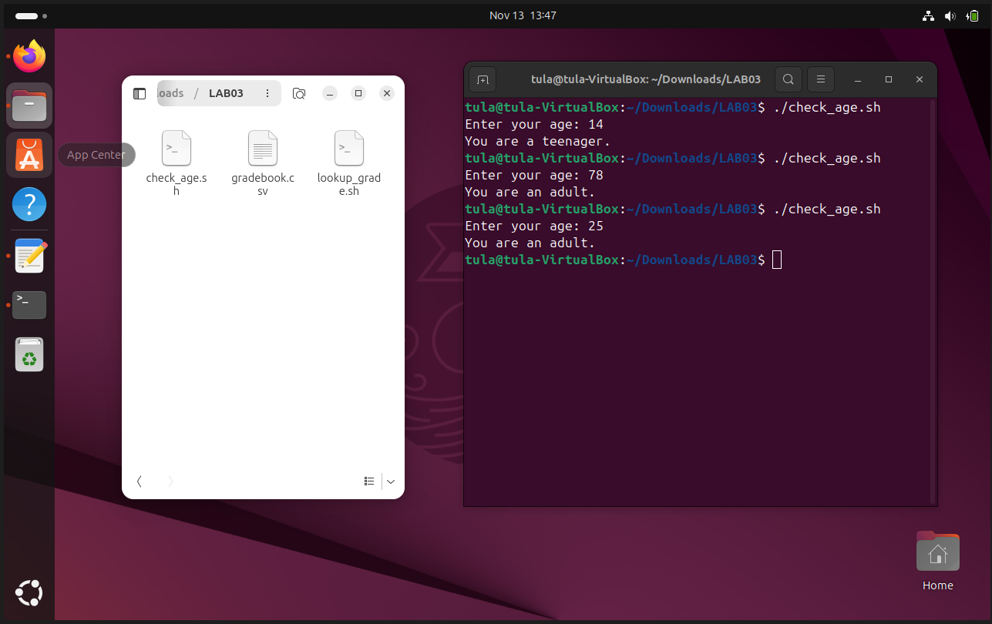

Check_age.sh
#!/bin/bash

read -p "Enter your age: " age

if ! [[ "$age" =~ ^[0-9]+$ ]]; then
echo "Error: Age must be a number."
exit 1
fi

age=$((age))

if [ "$age" -lt 0 ] || [ "$age" -gt 100 ]; then
echo "Error: Age must be between 0 and 100."
exit 1
fi

if [ "$age" -lt 12 ]; then
echo "You are a child."
elif [ "$age" -le 18 ]; then
echo "You are a teenager."
else
echo "You are an adult."
fi

Explanation:

1. Prompt for Age
read -p "Enter your age: " age
- Asks the user to type their age.
- Stores input in the variable age.

2. Check if Input is a Number
if ! [[ "$age" =~ ^[0-9]+$ ]]; then
echo "Error: Age must be a number."
exit 1
fi
- Uses a regular expression to verify that input contains only digits.
- If not, prints an error and ends the script.

3. Convert Input to Integer
age=$((age))
- Ensures the input is handled as a numeric value.

4. Check Age Range (0–100)
if [ "$age" -lt 0 ] || [ "$age" -gt 100 ]; then
echo "Error: Age must be between 0 and 100."
exit 1
fi
- Validates that the age is between 0 and 100.

5. Classify the User
if [ "$age" -lt 12 ]; then
echo "You are a child."
elif [ "$age" -le 18 ]; then
echo "You are a teenager."
else
echo "You are an adult."
fi
- Uses conditional statements to determine the age category.
- Prints the appropriate message.

3. Write a program that read 02 arguments from command line: first argument is a string while second argument is a path.
Check if that string exists in any text file (for example, test.txt) in the provided path. Print the line containing the string.

Answer:
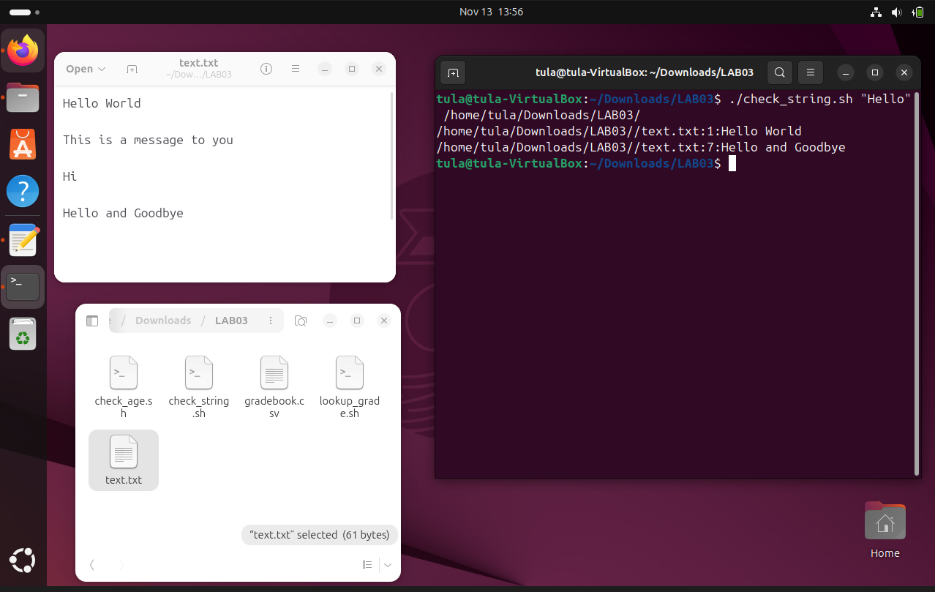

Check_string.sh
#!/bin/bash

if [ $# -ne 2 ]; then
echo "Usage: $0 <string> <path>"
exit 1
fi

search="$1"
path="$2"

if [ ! -d "$path" ]; then
echo "Error: '$path' is not a valid directory."
exit 1
fi

grep -nH -R -F "$search" "$path"/*.txt 2>/dev/null

if [ $? -ne 0 ]; then
echo "String '$search' not found in any text file in $path."
fi

Explanation:

1. Check Number of Arguments
if [ $# -ne 2 ]; then
echo "Usage: $0 <string> <path>"
exit 1
fi
- Ensures the user provides exactly two inputs.

2. Store Arguments
search="$1"
path="$2"
- Saves search text and target directory.

3. Check If the Path Is a Directory
if [ ! -d "$path" ]; then
echo "Error: '$path' is not a valid directory."
exit 1
fi
- Ensures the provided path exists and is a directory.

4. Search for the String
grep -nH -R -F "$search" "$path"/*.txt 2>/dev/null

Flag | Meaning
-n | Show line number
-H | Show filename
-R | Search recursively
-F | Treat pattern as a fixed string (not regex)
- Searches only .txt files.
- Hides warnings using 2>/dev/null.

5. Check grep Result
if [ $? -ne 0 ]; then
echo "String '$search' not found in any text file in $path."
fi
- If nothing is found, prints a message telling the user.

